Exploring Physic Stage 3: Set 13
NB: Some diagrams not included and only some written answer done.

- E = 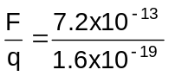
E = 4.5 x 10⁶ N C⁻¹

- The work done = force x distance
W = Fs
but F = Eq (unit N C⁻¹)
so W = Eqd
now from stage 2 Electrical Fundamentals, we know that W = Vq so
Vq = Eqd “q” will cancel out so
V = Ed or more commonly
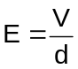 where: E = Electric field strength (V m⁻¹
V = voltage between plates (V)
d = distance between plates (m)

(Units V m⁻¹)

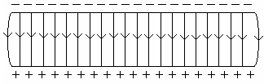
- a.

  - Had problems with this so I got help but we still get a different answer from the book. When the answers come out from STAWA, best check this as there must be a simpler way to do this.
F = Eq
= 2.5 x 10⁴ x 1.6 x 10⁻¹⁹
= 3.6 x 10⁻¹⁵ N downwards

F = ma 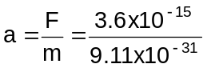
a = 3.995 x 10¹⁵ m s⁻²

horizontal: v = s/t
t = s/v
= 0.03 / 2.9 x 10⁷
t = 1.03 x 10⁻⁹ s

down v = at
= 3.995 x 10⁵ x 1.03 x 10⁻⁹
= 4.13 x 10⁶ m s⁻¹

components: down = 4.11 x 10⁶ 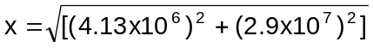
horizontal = 2.9 x 10⁷ = 2.929 x 10⁷ m s⁻¹
angle = tan⁻¹ (4.13 x 10⁶ / 2.9 x 10⁷
= 8.1⁰

so final velocity 2.93 x 10⁷ m s⁻¹ downwards at an angle of 8.1⁰
c. While horizontal velocity is unaffected by gravity. Electric field interacts with moving charged particle creating a vertical force and velocity and therefore velocity is resolution horizontal and vertical velocities.

d. Changing potential difference changes strength of electric field and alters both speed and direction of charged particles.

- E_{k} = Vq
= 1800 x 1.6 x 10⁻¹⁹
= 2.9 x 10⁻¹⁶ J

- F = ma E = 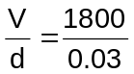
E = 6.00 x 10⁴ V m⁻¹ (or N C⁻¹ as they are the same)

- Many devices operate on radio waves and aluminium prevents radio waves from travelling through it.

- a. F = Eq W = Fs
= 2.2 x 10⁴ x 5.0 x 10⁻⁹ = 1.1 x 10⁻⁴ x 0.003
= 1.1 x 10⁻⁴ N = 3.3 x 10⁻⁷ J

b. V = Ed
= 2.2 x 10⁴ x 0.003
V = 66 V

- E = 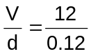

E = 100 V m⁻¹

- a and b. W = Vq
= 5000 x 1.6 x 10⁻¹⁹
= 8 x 10⁻¹⁶ J

in eV = 8 x 10⁻¹⁶ ÷ 1.6 x 10⁻¹⁹
= 5 000 eV
= 5 kV

- As alpha particle has lost two electrons, charge is 2 x 1.6 x 10⁻¹⁹ C

W = Vq
= 5000 x 2 x 1.6 x 10⁻¹⁹
= 1.6 x 10⁻¹⁵ J

in eV = 1.6 x 10⁻¹⁵ ÷ 1.6 x 10⁻¹⁹
= 10 keV

- a. E = 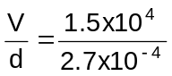 = 5.56 x 10⁷ V m⁻¹

  - F = Eq
= 5.56 x 10⁷ x 1.6 x 10⁻¹⁹
= 8.896 x 10⁻¹² N

W = Fs
= 8.896 x 10⁻¹² x 2.7 x 10⁻⁴
= 2.40 x 10⁻¹⁵ J

- a. Moving car develops a charge which is passed to driver’s shirt.
Charged shirt then attaches dust particles.

  - F = Eq
= 9.0 x 4 x 10⁻⁶
= 3.6 x 10⁻⁵ N

  - E_{k} = 3.6 x 10⁻⁷ J s = 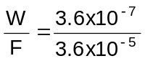
s = 0.01 m (10 mm)

V = 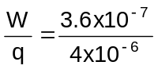
V = 0.09 V

- a. Collector chamber containing sets of electrodes in form of parallel plates which serve as grounded electrodes that act as particle collectors. Discharge electrodes, within but insulated electrically from the rest of the chamber, are charged with high direct current. A battery and solar cell produce direct current in which the current flows in one direction. The electrical charge ionizes the suspended particles, causing them to move toward the collecting electrodes. In a simple electrostatic precipitator, opposite high voltages are charged on two plates or grids. The positive grid charges the particles and the negative grid attracts them. If the material collected is dry, every so often the collecting electrodes are tapped to loosen the particles, which falls into hoppers for collection and disposal.

  - Burning coal produces exhaust gases that contain dust, ash and other impurities which are bad for human health and the environment so must be prevented from entering the atmosphere.

- Interesting question!!!!

- q = 1.6 x 10⁻¹⁹ C W = qV
V = 800 V = 1.6 x 10⁻¹⁹ x 800
= 1.28 x 10⁻¹⁶ J

E_{k} = ½ mv²
1.28 x 10⁻¹⁶ = 0.5 x 1.67 x 10⁻²⁷ x v²
v² = 1.533 x 10¹¹
v = 3.92 x 10⁵ m s⁻¹

- a.

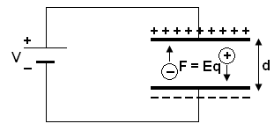

  - V = Ed
= 2.5 x 10⁴ x 0.10
= 2500 V

W = Vq
= 2500 x 1.6 x 10⁻¹⁹
= 4.0 x 10⁻¹⁶ J (2500 eV)

  - E_{k} = ½ mv²
4.0x10⁻¹⁶ = 0.5 x 9.11 x 10⁻³¹ x v²
v² = 8.78 x 10¹⁴
v = 2.96 x 10⁷ m s⁻¹

  - opposite to above

  - same charge so same kinetic energy

  - less as the mass is greater

- a. W = Vq
= 4000 x 1.6 x 10⁻¹⁹
= 6.4 x 10⁻¹⁶ J or 4000 eV

- E = 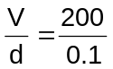 F = Eq
= 2000 V m⁻¹ = 2000 x 1.6 x 10⁻¹⁹
= 3.2 x 10⁻¹⁶ N

- diagram not included

- a. To remove any air particles that would interfere with the electrons

b. F = ma E = 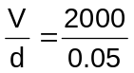 F = Eq
= 40000 V m⁻¹ = 40 000 x 1.6 x 10⁻¹⁹
= 6.4 x 10⁻¹⁵ N

a = 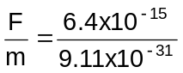
a = 7.02 x 10¹⁵ m s⁻¹

c & d Not included.

